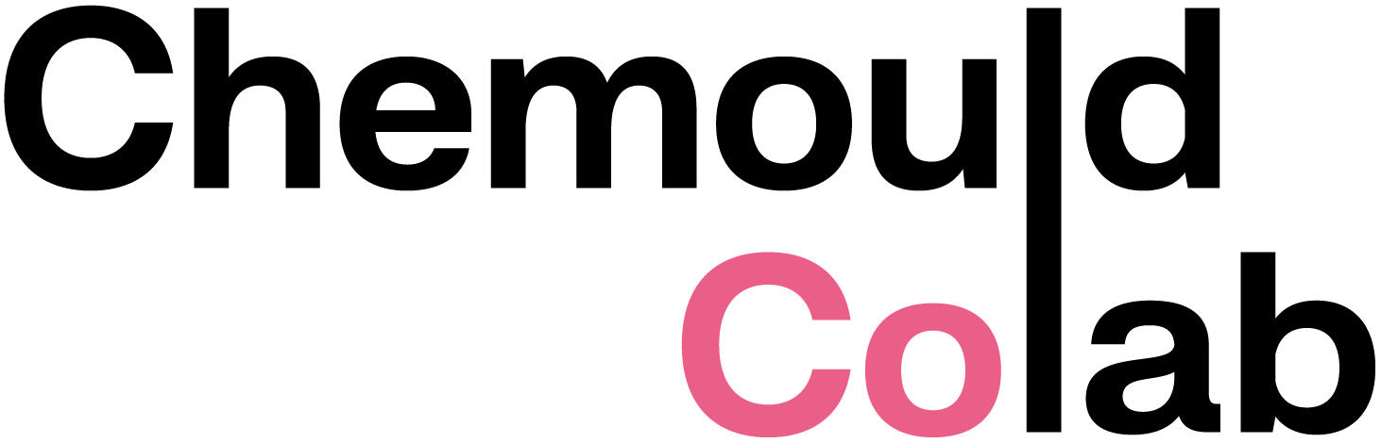
CV
RACHITA DUTTA
b.1993
EDUCATION
2017 MFA (Painting), Kala Bhavan, Visva Bharati University
2015-17
2015 BVA (Painting) , IMFA , Jammu University, 2011-15
SOLO EXHIBITIONS
2026 Have We Forgotten How To Feel?, Chemould CoLab, Mumbai
2015 The Falling Leaves, Solo Show, Rinchen Bzangpo Art Gallery, University of
Jammu
GROUP EXHIBITIONS
2026 India Art Fair 2026, Mumbai
2025 Touch Beyond The Surface, Rukshaan Art, Mumbai
2024 The Baroda March, The Stainless Art Gallery, New Delhi
2024 The Winter Show, Round Them Oranges, Jaipur
2023 Raag, Dot Line Space Art Gallery, Mumbai
2023 63rd National Lalit Kala Exhibition, New Delhi
2023 Tender Buttons and a Bellyache, Apre Art House, Mumbai
2022 World Within World Without, Bikaner House, New Delhi
2021 Pause, Nippon Art Gallery, Mumbai
2021 A Tale To tell, Tsechulaom Art Gallery, Ladakh
2021 Akshayapatra, National Women Artist Art Exhibition, Lalit Kala Gallery,
New Delhi
2020 HIMAJ, International Virtual Art Exhibition, CUHP
2017 Simeesha Studio, Faculty of Fine Arts, Vadodara
2016 Bombay Art Society, Annual Group Show, Jehangir Art Gallery, Mumbai
2015 4th All India Women Art Exhibition , Chandigarh
2015 State Annual Art Exhibition , J&K Academy, Kala Kendra, Jammu
2014-2015 Student’s Biennale, Fort Kochi, Kerala
SCHOLARSHIPS
2022 Junior Fellowship Award by CCRT
2017 National Young Artist Scholarship by CCRT
SELECTIONS
2023 Lalit kala National Art Exhibition, New Delhi
2020 Icelandic Textile Art Residency, Iceland
ART RESIDENCY
2025 Chemould CoLab, Mumbai
2023 Apre Art Residency, Mumbai
COLLECTION
Head Office, Zydus Medical Company, Ahmedabad.
Private Collection in Delhi and Mumbai.
AWARDS
2019 State Award for New Media (Textile), Jammu and Kashmir Prafulla Dhanukar
Art Foundation, India.
2018 North Zone Silver Award (Textile), Prafulla Dhanukar Art Foundation, India.
2017 Women Artist State Award (Installation), West Bengal, Prafulla Dhanukar Art
Foundation, India.
2015 First Prize (Installation), 30th National Youth Festival, Indore, India.
2015 First Prize (Installation), North Zonal Youth Festival, University of Jammu,
India.
2014 First Prize (Painting), Display Your Talent, University of Jammu, India.
2014 First Prize (Photography), Display Your Talent, University of Jammu, India.
2013 Second Prize (Painting), Display Your Talent, University of Jammu, India.
CAMPS
2024 Sama Vaya, Five Days Art Camp organized by Anupa Mehta Contemporary at
Skyview, Patnitop
2024 SARJNA, Five Days Painting Camp, University of Jammu
2022 Kala Kumbh, Ten Days Painting Camp, organized by NGMA, Chitkara
University
2021 All India Women’s Camp, organized by Lalit Kala Academy, Garhi Studios,
New Delhi
2018 Painter’s Camp, organized by NZCC, Srinagar
2018 The 18 Collisions Art Workshop, organized by Lalit Kala Academy, Chandigarh
2016 Cartist Artist Painting Workshop, Jaipur

TEACHING EXPERIENCE
Since 2023 Serving as a Painting Lecturer in IMFA, University of Jammu.
2019-20 Served as a Painting Lecturer in IMFA, University of Jammu.
2023 Drawing with Thread Workshop, Apre Art House, Mumbai.
2022 Naimisha Art Workshop ( Painting and Textile), NGMA, New Delhi.
2021 FCC- Liberal Art, Open Elective Workshop, Symbiosis Institute of Design,
Pune.
2021 One Week Online Textile (Fabric Collage and Embroidery) Art Workshop,
The Daly College, Indore.
2020 External Jury for Foil Sculpture Art Competition, The Daly College, Indore.
2020 Ten Days Online Textile (Fabric Slashing, Tie and Dye and Embroidery) Art
Workshop, The Daly College, Indore.
2020 Naimisha Art Workshop (Painting), National Gallery of Modern Art,
New Delhi.
2019 Paper Cuts and Colors Collage Art Workshop, Jammu.
2017 Painting Workshop with Physically challenged students in collaboration with
Simeesha Studio, Bharuch, Gujarat.

