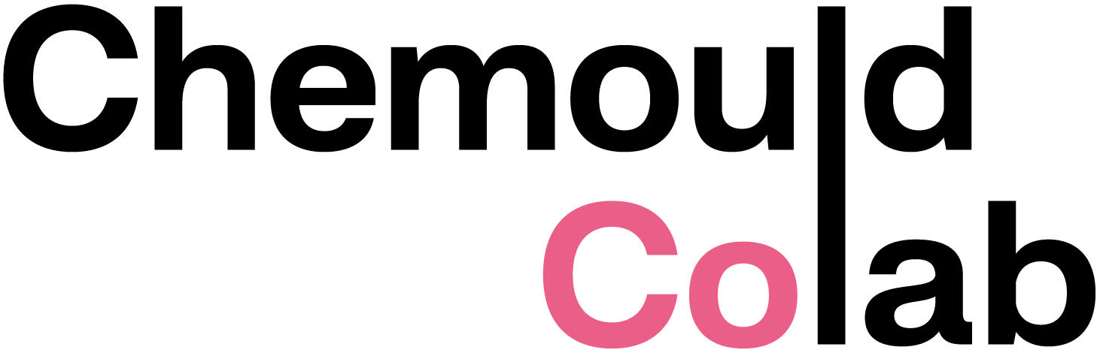

CV
GURJEET SINGH
b. 1994, in Punjab, India

EDUCATION
2019 MFA, Gold Medalist Recipient, Govt. College of Art, Chandigarh, India
2017 BFA, Govt. College of Art, Chandigarh, India

SOLO EXHIBITIONS
2026 I Got a Cut in my Flower Valley, Rajiv Menon Contemporar, Los Angeles, California, USA
2025 Dreamers, Gurjeet Singh x Jaipur Rugs, Chemould CoLab at Chemould Prescott Road, Mumbai, India
2024 To kill a bully with kindness, Chemould CoLab, Mumbai, India
2022 This Is What It’s Like To Be Fabulous, Chemould CoLab, Mumbai, India

PROJECTS/COMISSIONS
2022 Visible/Invisible: Representation of Women in Art throughout the MAP
Collection, commission by Museum of Art and Photography, Bangalore, India
2022 Remains of waste, Chemould CoLab x BODICE x India Art Fair, New Delhi, India
2022 Issue 1.5: A Final Freedom, cover commission for The Dirty Magazine, shot by
Bikramjit Bose, Mumbai, India

GROUP EXHIBITIONS
2025 Prick! Needlework now, RMIT Gallery, Melbourne, Australia
2024 Now Streaming, Rajiv Menon Contemporary, Los Angeles, California
2024 Mind Echo, Chemould CoLab, Mumbai, India
2024 Almost Gods X India Art Fair 2024 X Young Collectors Program, New Delhi, India
2023 Continuum (after Jitish Kallat), 60 Years of Gallery Chemould, Chemould
CoLab, Mumbai, India
2023 British Textile Biennial, Fragments, curated by Uthra Rajgopal, Whitaker
Museum and Art Gallery, UK
2022 A Line Fine, Goa Brewing Company, Goa, India
2022 Rehang, Anant Art Gallery, New Delhi, India
2021 License to laugh, Curated by Lina Vincent, Shrishti Art Gallery, Hyderabad, India
2019 Goa Affordable Art Fest, Museum of Goa, Goa, India
2018 Saksham Sparsh Art Foundation, Punjab Kala Bhawan, Chandigarh, India
2018 Eastern Foundation of Art & Culture, Jodhpur, Rajasthan, India
2018 Chandigarh Lalit Kala Academy Exhibition, Chandigarh, India
2016 Rabindra Bhawan, Organised by Chandigarh Lalit Kala Akademi, New Delhi, India
2015 Nehru Centre, The High Commission of India, London, UK

RESIDENCIES
2026 Jaipur Art Week, Jaipur Rugs, Jaipur, India
2026 The Space Between Us, Foundation FIMINCO, Paris, France
2025 Hampi Arts Labs, Hampi, India
2023 Jaipur Rugs, Jaipur, India
2022 Chemould CoLab, Mumbai, India
2022 India Art Fair, Artist in Residence 2022, New Delhi, India
2021 HH Art Spaces, Goa, India
2020 SPACE STUDIO, Sculpture Residency, Baroda, India
2019 KHOJ International Artists’ Association – PEERS, New Delhi, India

GRANTS & SCHOLARSHIPS
2023-25 Next Generation India Fellow, UN Foundation and CEEW The Council, New York / India
2023 PCLKA Scholarship to visit museums and art galleries in London, Chandigarh Lalit Kala Academy, Chandigarh, India
2020 KHOJ Support Grant by KHOJ International Artists Association, New Delhi, India
2020 Shrishti AIF Grant by Shrishti Art Gallery, Hyderabad, India
2019 Scholarship, Punjab Lalit Kala Akademi, Chandigarh, India
2018 Kochi Muziris Biennale, National Travel Grant by Punjab Lalit Kala Akademi,
Chandigarh, India

AWARDS
2023 VOGUE Forces of Fashion, Mumbai, India
2022 Punjab Lalit Kala Akademi Award in the Professional Section, Punjab, India
2021 Inlaks Fine Art Award by Inlaks Shivdasani Foundation, New Delhi, India
2020 HT top thirty under thirty by Hindustan Times, Chandigarh, India
2019 Amrita Shergil Award, Government College of Art, Chandigarh, India
2018 Annual Art Exhibition, Punjab Lalit Kala Academi, Chandigarh, India
2018 Punjab State Award, Prafulla Art Foundation, Punjab, India
2017 Himachal State Museum, Shimla, India
2014 Himachal State Museum, Shimla, India

COLLECTIONS
Asian Art Museum of San Francisco, California, US KADIST collection Paris
Museum of Art and Photography (MAP), Bangalore, India
Kiran Nader Museum of Art, Delhi, India

The artist lives and works in Chandigarh, India.

