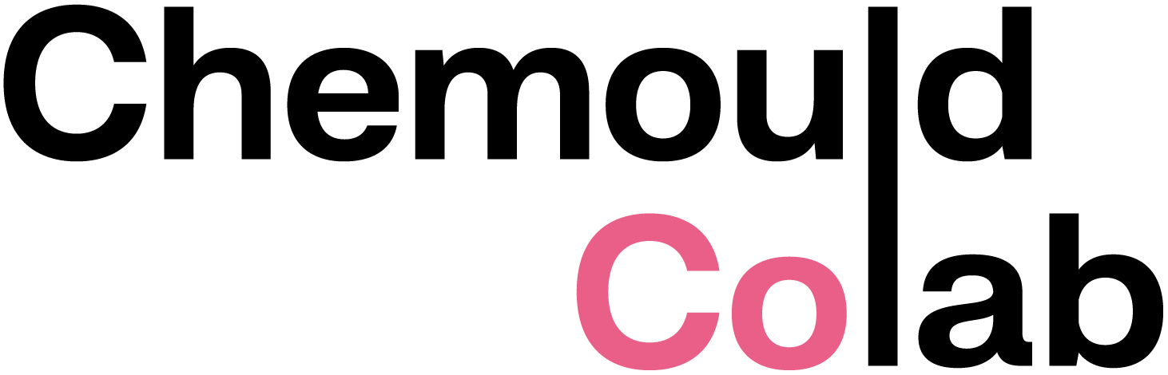

CV
JAYEETA CHATTERJEE
b. 1995, West Bengal, India

EDUCATION
2020 MFA, Printmaking, Faculty of Fine Arts, Maharaja Sayajirao University of Baroda, India
2018 BFA, Printmaking, Kala Bhavan, Visa Bharati, Santiniketan, West Bengal, India

SOLO EXHIBITIONS
2024 An Eye Inside, Chemould Prescott Road, Mumbai, India

GROUP EXHIBITIONS
2023 Continuum (after Jitish Kallat), Chemould CoLab, Mumbai, India
2022 Triloka, Shrishti Art Gallery, Hyderabad, India
2022 Yours in truth, curated by Saloni Doshi, Space 118, Mumbai, India
2022 Ask the cloud to remember, curated by Shreemoyee Moitra, Akara Art Gallery, Mumbai, India
2022 Immerse, curated by Shaleen Wadhwana, in association with Young Art Support, Somaiya Trust, Carpe Arte, Somaiya Vidyavihar Univeristy, Mumbai, India
2021 FIRST TAKE 2021, presented by Abir India, Hutheesing Center Ahmedabad, India
2021 Emerging Palettes, Shrishti Art Gallery, Hyderabad, India
2021 Manorama Young Printmaker Award 2021 Exhibition, presented by India Printmaker House, online
2021 AI Curates Best 100 Artists Projects
2021 Khajuraho Artmart exhibition, Madhya Pradesh, India
2020 Satah, Maharaja Sayajirao University of Baroda, India
2020 Space 118 x Faculty of Fine Arts, Maharaja Sayajirao University of Baroda, India
2019 Haugesund International Relief Print Festival, Norway
2018 7th Ulsan International Woodcut Print Festival, South Korea
2018 Plotion, Kala Bhavan Annual Exhibition, ICCR, Kolkata, India
2017 Printmaking award exhibition, Santiniketan Society of Visual Art and Design, West Bengal, India
2016 Santiniketan awards print exhibition, Nandan Museum, Kala Bhavan, Visva Bharati, West Bengal, India

RESIDENCIES
2024 Hampi Art Labs, Karnataka, India
2023 Chemould CoLab, Mumbai, India

2022 Immerse, Artist in residence, curated by Shaleen Wadhwana, in association with Young Art Support, Somaiya Trust, Carpe Arte, Somaiya Vidyavihar University Mumbai, India
2021 KHOJ PEERS, New Delhi, India
2021 Banyan Hearts, Hyderabad, India
2017 National level student art camp, CKP Bangalore, India

AWARDS
2026 30 Under 30 Artists Award, Art India Magazine
2025 Asia Arts Future Award India, Asia Society India Centre
2021 Manorama Young Printmaker Award 2021 Exhibition, presented by India Printmaker House
2021 Eleventh week winner of Artdemic
2021 Shortlisted for The Arts Family London (TAF) Emerging artist award – South Asia 2021
2019 Haugesund International Festival of Relief Printing (HIT 2019),
Norway
2017 Santiniketan Society of Visual Art and Design (SSVAD) annual
exhibition, Santiniketan
2017 Printmaking award exhibition, Santiniketan Society of Visual Art and Design, West Bengal, India
2016 Santiniketan awards print exhibition, Nandan Museum, Kala Bhavan, Visva Bharati, West Bengal, India

The artist lives and works in Bangalore, India.

